The First People of Awaba "Awaba" is the Aboriginal name for Lake Macquarie, near the city of Newcastle, New South Wales, and "Awabakal" is the name of the people who come from this area, and the language they once spoke. From 1804, the penal settlement at Newcastle began the English takeover of the Newcastle and Lake Macquarie area. A devastating outbreak of smallpox among the Aboriginals, witnessed by the First Fleet in 1789, probably killed up to one-third of the aboriginal population of the Newcastle-Lake Macquarie region. Although the smallpox did not originate with the fleet, it did weaken the Aboriginal people’s resistance to the Europeans.
The relationships between Aboriginals and Europeans at Newcastle were, on the whole, relatively friendly. Aboriginals traded meat and fish for blankets and clothing. The penal settlement was a reasonably well supervised operation, posing little threat to the freedom and survival of local Aboriginal peoples. It was after the closure of the settlement that trouble began. Lands were taken from aboriginal people by force as settlers moved into the area to get timber and coal, and set up farming and grazing.
In 1826 Reverend Lancelot Threlkeld set up an Aboriginal mission in the Lake Macquarie district and with the help of Birabahn developed a good relationship between the indigenous people and the Europeans.
The Early Development of Awaba
The town of Awaba is on Lake Macquarie, a large coastal saltwater lake which lies between the Pacific Ocean and the Watagan Mountains of New South Wales. The lake is about 100 km north of the city of Sydney and 20 km south of the city of Newcastle.
In 1885 a timber depot was established and a large saw mill was an early feature of the town. Timber was hauled to the depot by bullock team from Mulbring, Brunkerville, Mount Vincent and Wallis Plains. Timber workers were the area's pioneers and included the Field, Wellard, Puddy and Murrell families. They lived in slab huts built on the site of the old Awaba Sports Ground.

Also in 1885 Awaba was selected as a site for a railway construction depot. The village developed in response to the needs of the railway workers and homes were scattered over a wide area. There were no street names at first. The first street plan in 1892, consisted of Barton St, Melbourne St, Brisbane St, Gosford St, Nellinda St, Heaton St and Adelaide St. Settler operated a small general store, a bakery and a primitive butcher's shop. A Post Office opened 1 October 1889 and the Public school opened in June 1891.

Awaba Public School

The timber and railway depots gave employment to many timber getters and fettlers, many of them married men with families. In 1890 the population of Awaba was 80 and so the Inspector of Schools decided to build a public school.

A substantial brick school building was constructed in 1891 and provided an interesting contrast to the rough slab huts in the village. The first teacher was Isabel McDonald with 18 to 21 pupils. Emily Peak , one of Awaba’s first teachers, operated under difficult conditions. There was no school residence so the she had to live in a bark hut, which was cold and damp in the wet or stifling hot in the summer. She later decided to commute by horse from Toronto.

Many teachers have taught at Awaba but the longest serving teacher at Awaba was Mr John Hallinan 1942-1967. There are 27 children at our school now in 2011. The original building is still in use but we have three more buildings and a large covered outdoor learning area. Awaba Public School has seen many changes over the years but is still the hub of the town.

Awaba Public School

The timber and railway depots gave employment to many timber getters and fettlers, many of them married men with families. In 1890 the population of Awaba was 80 and so the Inspector of Schools decided to build a public school.

A substantial brick school building was constructed in 1891 and provided an interesting contrast to the rough slab huts in the village. The first teacher was Isabel McDonald with 18 to 21 pupils. Emily Peak , one of Awaba’s first teachers, operated under difficult conditions. There was no school residence so the she had to live in a bark hut, which was cold and damp in the wet or stifling hot in the summer. She later decided to commute by horse from Toronto.

Many teachers have taught at Awaba but the longest serving teacher at Awaba was Mr John Hallinan 1942-1967. There are 27 children at our school now in 2011. The original building is still in use but we have three more buildings and a large covered outdoor learning area. Awaba Public School has seen many changes over the years but is still the hub of the town.

Coal Mining in Awaba

The presence of coal in Awaba has been known since 1883. During the next eighty years there was no major mining activity but some small mines tapped into the coal seam. These small mines were very primitive and the workers’ safety was always at risk. The most remembered of these small mines is “The Blowfly” which was worked in 1932 by four miners who were paid £1 a day. A pony and skip was used to take the coal out of the mine then the coal was taken to Awaba Railway Station.

Mining at the Awaba State Mine began in 1947 and had a significant impact on Awaba residents because it provided a secure source of employment for them. The Awaba Mine was the second mine owned by the State Government and was developed to supply coal to the Wangi Wangi Power Station to make electricity. The mine produced one hundred tons of coal a day and employed forty men.

The Wangi Power Station was replaced by the Eraring Power Station in 1982 and the coal is hauled there on a privately constructed road. In 2005 Centennial Coal, who now own the mine, tried to open an open cut mine in Awaba near our school but this was stopped by the actions of the community.
The Future for Awaba
One of the key elements that people living in Awaba wish to retain into the future is our relaxed lifestyle and sense of wellbeing. What must we do to ensure that the necessary infrastructure, suitable housing, community facilities and employment opportunities are provided?
What do we need to do to attract new industries and generate a wider range of secure and local jobs? How do we ensure there is a strong local food production industry supplying Awaba with local produce? How do we make our houses more sustainable by using renewable energy? Are there new ways of doing business that need to be adopted in the future?
What needs to be done to improve public transport and rail services? How do we make it easier and safer to get around our region and reduce our dependency on cars? Is the concept of catching public transport anywhere, anytime achievable? What elements of our history and heritage are important for us to preserve? What lessons can we learn from our past?

Chapter Summary
- The Constitution sets out the areas of responsibility for the federal government. The federal government cannot act beyond these areas.
- Generally these areas concentrate on matters of national or international importance.
- Areas of responsibility not given to the federal government will be the responsibility of the States.

Introduction
The federal government makes laws in relation to its areas of responsibility which are set out in the Constitution. Generally these areas have national or international importance. Any responsibility not specifically given to the federal government by the Constitution will be the responsibility of the State parliaments.

Areas of responsibility
The federal government is responsible for making laws and determining policy in relation to the following areas:
- Banking, Taxation and Currency: the federal government decides how it will raise money by charging taxes and how it will spend money on behalf of Australian citizens. The federal government also looks after the nation's money system (currency) through its appointed body the Reserve Bank of Australia.
- Airports and Air Safety: looking after airports, air traffic control, and safety services at airports such as fire fighting services.
- Defence: the federal government has the responsibility of operating the country's armed forces.
- Foreign Affairs: the federal government, through the Foreign Minister, is responsible for Australia's relations with the rest of the world.
- Industrial Relations: generally disputes between employers and employees are dealt with under State laws. If the dispute, however spreads to more than one State, federal laws will apply.
- Immigration: the movement of people into Australia is controlled by the federal government through the Department of Immigration and Multicultural Affairs.
- Postal Services: Australia Post, run by the federal government, operates Australia's postal services.
- Social Services and Pensions: paying pensions to the disabled, elderly and unemployed.
- Telecommunications and Broadcasting: laws in relation to radio, television, the internet and satellite communication are all made by the federal government.
- Trade: through the Department of Foreign Affairs and Trade the federal government controls the import of overseas goods and the export of Australian goods.

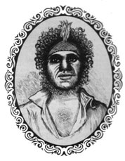
"Biraban (McGill)", 1839, from
John Fraser's,
Art Australian Language
(Fraser 1892: 88a)

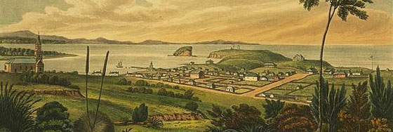

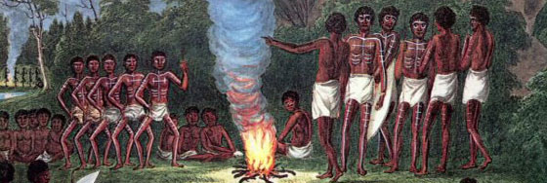
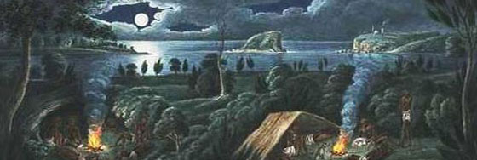
AWABA: THEN AND NOW
____________________________________________________
The aboriginal people of Awaba would have eaten berries, wallabies and ________.
In 1826 Reverend Lancelot Threlkeld set up an aboriginal mission in Lake Macquarie and with the help of ________________ developed a good relationship between the indigenous people and the Europeans.
In 1885 Awaba was the depot for the timber workers of the district and for the construction of the __________________.
The forests around Awaba were filled with a lovely, red timber called _________.
Awaba Public School was built in ________ to cater for the children of the timber workers and the fettlers.
The Awaba State Coal Mine began in 1947 and provided a secure source of __________________ for the residents.
The Awaba State mine was developed to supply ________ to the Wangi Wangi Power Station to make electricity.
Wangi Power Station was replaced by The _____________ Power Station in 1982.
Draw Awaba in 1891 Draw Awaba in 2051

