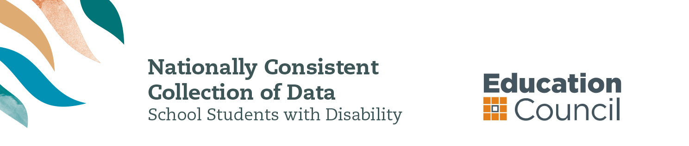

Information for parents and carers

WHAT IS THE NATIONAL DATA COLLECTION?
The Nationally Consistent Collection of Data on School Students with Disability (the national data collection) is an annual collection that counts the number of school students receiving an adjustment due to disability and the level of reasonable adjustment they are receiving.
The national data collection counts students who have been identified by a school team as receiving an adjustment to address a disability as defined under the Disability Discrimination Act 1992 (the DDA). The DDA can be accessed from the ComLaw website at www.comlaw.gov.au.

what is the benefit for my child?
The aim of the national data collection is to collect quality information about school students receiving an adjustment due to disability in Australia.
This information will help teachers, principals, education authorities and families to better support students with disability to take part in school on the same basis as other students.
The national data collection provides an opportunity for schools to review their learning and support systems and processes to continually improve education outcomes for their students with disability.

WHY IS THIS DATA BEING COLLECTED?
All schools across Australia collect information about students with disability. But the type of information currently collected varies between each state and territory and across government, Catholic and independent school sectors.
When undertaking the national data collection, every school in Australia uses the same method to collect information. Therefore, a government school in suburban Sydney collects and submits data in the same way as a Catholic school in country Victoria and an independent school in the Northern Territory.
The annual collection aims to, over time, lead to nationally consistent, high quality data that will enable schools, education authorities and governments to gain a more complete understanding of students who are receiving adjustments because of disability in schools in Australia, and how to best support them.

WHAT ARE SCHOOLS REQUIRED TO DO FOR STUDENTS WITH DISABILITY?
All students are entitled to a quality learning experience at school.
Schools are required to make reasonable adjustments, where needed, to assist students with disability to access and participate in education free from discrimination and on the same basis as other students.
These responsibilities are outlined in the DDA and the Disability Standards for Education 2005 (the Standards). The Standards require educators, students, parents and others (e.g. allied health professionals) to work together so that students with disability can participate in education. The Standards can be accessed via the ComLaw website at www.comlaw.gov.au.

WHAT IS A REASONABLE ADJUSTMENT?
A reasonable adjustment is a measure or action taken to help a student with disability access and participate in education on the same basis as other students. Reasonable adjustments reflect the assessed individual needs of the student, and are provided in consultation with the student and/or their parents and carers. Reasonable adjustments can be made across the whole school setting (e.g. ramps into school buildings), in the classroom (such as adapting teaching methods) and at an individual student level (e.g. extra tuition for a student with learning difficulties).

What information will be collected?
Every year your child’s school will collect the following information for each student receiving an adjustment due to disability:
- the student’s level of education (i.e. primary or secondary)
- the student’s level of adjustment
- the student’s broad type of disability.
The information collected by schools will be available to all governments to inform policy and program improvement for students with disability.

WHO IS INCLUDED IN THE NATIONAL DATA COLLECTION?
The definition of disability for the national data collection is based on the broad definition under the DDA.
For the purposes of the national data collection, students with learning difficulties, such as dyslexia or auditory processing disorder, as well as chronic health conditions like epilepsy or diabetes, that require monitoring and the provision of adjustments by the school, may be included.

Who collectS information FOR THE NATIONAL DATA COLLECTION?
Teachers and school staff count the number of students receiving an adjustment due to disability in their school, and the level of reasonable adjustment they are provided, based on:
- consultation with parents and carers in the course of determining and providing reasonable adjustments
- the school team’s observations and professional judgements
- any medical or other professional diagnosis
- other relevant information.
School principals are responsible for ensuring the information identified about each student is accurate.

How IS my child’s privacy protected?
Protecting the privacy and confidentiality of all students and their families is essential and is an explicit focus of the national data collection. Personal details, such as student names or other identifying information, are not provided to local or federal education authorities.
Further information about privacy is available from www.education.gov.au/notices.

IS THE NATIONAL DATA COLLECTION COMPULSORY?
Yes. All education ministers agreed to full implementation of the national data collection from 2015. This means that all schools must now collect and submit information annually on the number of students receiving adjustments due to disability in their care, and the level of adjustment they receive.
Information about the arrangements that may apply to your school in relation to this data collection is available from your child’s school principal and the relevant education authority.
FURTHER INFORMATION
Contact your child’s school if you have further questions about the Nationally Consistent Collection of Data on School Students with Disability.
You can also visit www.education.gov.au/nationally-consistent-collection-data-school-students-disability.
An e-learning resource about the Disability Standards for Education 2005 is freely available for the use of individuals, families and communities at http://resource.dse.theeducationinstitute.edu.au/.

